**FSD Lab Assignment No:01**

**Name: Viren Kulkarni**

**PRN:1032220850**

**Batch: I1**

**Panel: I**

**Roll Number: PI-8**

**Aim:** Version control with Git.

**Objectives:**

1. To introduce the concepts and software behind version control, using the example of Git.
2. To understand the use of 'version control' in the context of a coding project.
3. To learn Git version control with Clone, commit to, and push, pull from a git repository.

**Problem Statement:**

Create a public git repository for your team and submit the repo URL as a solution to this assignment, Learn Git concept of Local and Remote Repository, Push, Pull, Merge and Branch.

**Theory:**

* What is Git? What is Version Control?

Git is a distributed version control system that tracks changes in code, allowing multiple developers to collaborate efficiently. It records history, supports branching and merging, and provides each developer with a full project copy.

Version control systems (VCS) manage changes to files over time. They enable collaboration, track history, and allow reversion to previous versions. VCS are either centralized (e.g., SVN) or distributed (e.g., Git), with distributed systems offering each user a complete project history. Benefits include collaboration, backup, and accountability.

* How to use Git for version controlling?

Use git init to create a new repository.

Clone a Repository: Use git clone <repository_url> to copy an existing repository.

Track Changes: Use git add to stage changes and git commit to save them.

Branching: Create a branch with git branch <branch_name> and switch to it using git checkout <branch_name>.

Merging: Merge branches using git merge <branch_name>.

Push and Pull: Use git push to upload changes and git pull to fetch updates from a remote repository.

Resolve Conflicts: Handle merge conflicts when they arise.

View History: Use git log to see the history of commits.

**FAQ:**

1. What is branching in Git?

1. Branching in Git is a feature that allows developers to diverge from the main codebase to develop, test, or fix code independently. Each branch is an isolated environment, which helps in managing different aspects of development without interfering with the stable code.

2. How to create and merge branches in Git ? Write the commands used.

A.

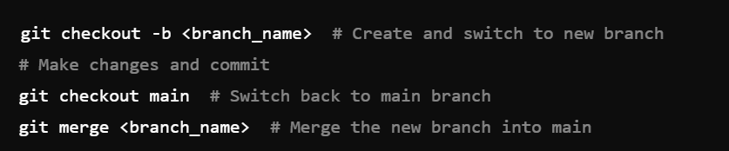

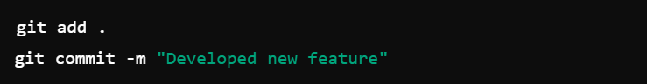

**Output:**